Consumers are More Connected to Mobile Ads
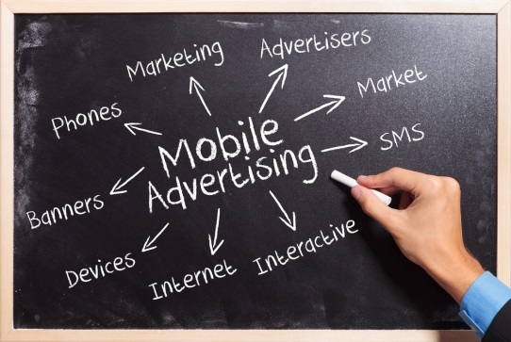
Consumers are engaging with mobile advertisement and services more than ever before, the latest study from the Interactive Advertising Bureau has found. Increased access to Wi-Fi, the proliferation of mobile devices and greater social media presence are all contributing factors to the increase, said Anna Bager, senior vice president of mobile and video at IAB.
The Drum (Glasgow, Scotland) 9/27/16
http://www.thedrum.com/news/2016/09/27/new-iab-survey-shows-consumers-buying-mobile-more-ever-ads-and-social-trigger
image source:
https://www.bing.com/images/search?q=mobile+phone+advertising&view=detailv2&&id=63DFB0EEBE7D35101763BF5F8FA63A715084D465&selectedIndex=30&ccid=eil6Lo6B&simid=608035596390696045&thid=OIP.M7a297a2e8e81f2422def618cf54cbce1o0&ajaxhist=0

