Consumers Can’t Tell the Difference Between Sponsored Content And Editorial

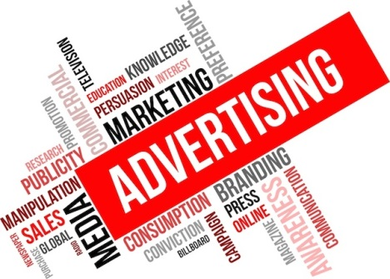
No matter what kinds of disclosures or design tweaks sponsored articles receive on leading online publications, consumers continue to confuse sponsored content (aka native advertisements) with actual articles, according to the latest survey from Contently.

Marketing Land 9.11.15

http://marketingland.com/consumers-cant-tell-the-difference-between-sponsored-content-and-editorial-142050

