Content Marketing, Branded Entertainment Growing
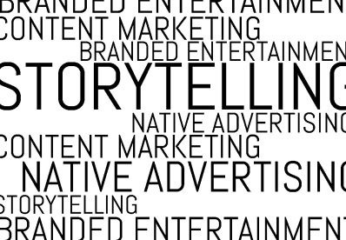
Branded entertainment investment is growing twice as fast as advertising spend, and content marketing spend is expected to increase by 15% this year, per PQ Media. "The picture is far rosier for brands than for the ad industry, provided we recognize the opportunities available to us," Rachel Haberman writes.
The Content Standard 4/23/18
https://www.skyword.com/contentstandard/creativity/branded-entertainment-growing-twice-as-fast-as-advertising-spend-study-finds/
Image credit:
http://www.story-making.com/wp-content/uploads/2014/11/Blog6-e1417015475298.jpg

