Rise Of Streaming, OTT Hurting Subscription TV
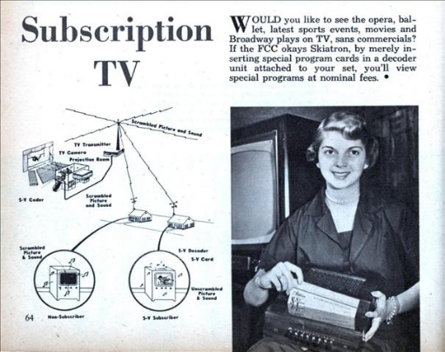
Parks Associates reports that 7 million television subscriptions were cancelled last year, and operators lost a total of 18 million pay-TV accounts between 2014 and 2020. The rise of over-the-top and streaming content has driven a drop in carriage fees and retransmission deals, increasing the shift to streaming by broadcasters and programmers.
TV Tech 7/11/21
https://www.tvtechnology.com/news/the-cost-of-ott-18-million-pay-tv-subs-lost-2014-2020
Image credit:
http://blog.modernmechanix.com/mags/qf/c/MechanixIllustrated/9-1953/med_subscription_tv.jpg

