Could Original Netflix Shows End Up On Linear TV?
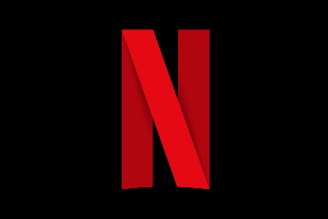
Netflix, which spent more than $17 billion on content last year, is reportedly considering licensing its original movies and shows to NBCUniversal and ViacomCBS. The video-on-demand giant licensed episodes of "BoJack Horseman" to ViacomCBS' Comedy Central in 2018.
Next TV 3.14.21
https://www.nexttv.com/news/netflix-has-reportedly-discussed-licensing-shows-to-media-companies

