Court Battle Continues Over Pre-1972 Recording Rights
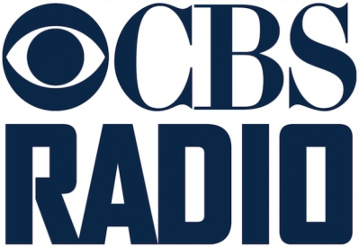
Attorneys for CBS Radio last week argued before the US Court of Appeals that digital recordings used by CBS Radio stations were new recordings and therefore should not be subjected to royalties for pre-1972 recordings. ABS Entertainment continues to push for royalty payments for songs that were originally published before Feb. 15, 1972, but CBS attorney Robert Schwartz said in court, "The purpose of the remastering of these recordings is to create something that sounds completely different."
Inside Radio 11/14/17
http://www.insideradio.com/free/cbs-argues-for-right-not-to-pay-for-pre-/article_e1f6b5f6-c91d-11e7-865f-07e7382d02d8.html

