Cumulus Renews Rush in Multi-Million Dollar Deal
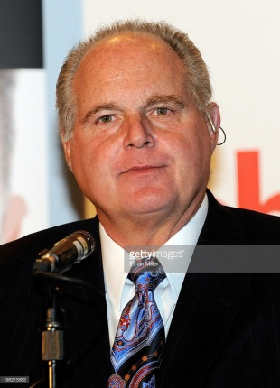
The 3-year deal between Premiere Networks and Cumulus will keep Rush on 33 Cumulus stations through 2019. Rush recently celebrated 28 years on the air. Back in August, Rush signed a new 4-year deal with Premiere to syndicate his program. Cumulus stations that carry Rush include: WLS-AM in Chicago, WJR-AM in Detroit, WMAL-FM in Washington, D.C., WBAP-AM in Dallas, and KSFO-AM in San Francisco.
RadioInk 12.14.16

http://radioink.com/2016/12/14/cumulus-renews-rush-multi-million-dollar-deal-2019/?utm_source=ActiveCampaign&utm_medium=email&utm_content=Are+Rush+s+Numbers+Proof+Talk+Radio+Is+Far+From+Dead%3F&utm_campaign=Thursday+12+15+Rush
Image source:
http://media.gettyimages.com/photos/radio-talk-show-host-and-conservative-commentator-rush-limbaugh-one-picture-id96215653

