Data Privacy "Nutrition Labels" Coming to iOS, Mac Apps
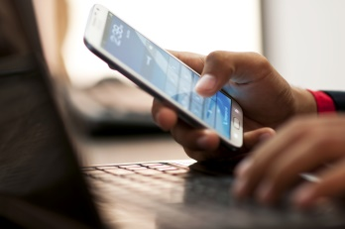
Apple soon will require app developers to provide information about the data their apps collect from users and present it as a list -- much like a nutrition label on food packaging -- that can be viewed before the app is downloaded. The requirement starts Dec. 8, though developers can begin submitting the information now.
The Verge 11.5.20
https://www.theverge.com/2020/11/5/21551926/apple-privacy-developers-nutrition-labels-app-store-ios-14
Image credit:
https://cebca.files.wordpress.com/2014/11/187625854.jpg

