Data Show Effect of Mobile Devices on TV Watching Among 18-34 Group
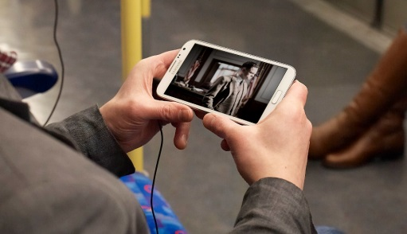
The number of people in the 18-34 demographic using smartphones, tablets or TV-linked devices jumped 26% in May to an average of 8.5 million per minute, per Nielsen data. Meanwhile, the number of people in the group using traditional TV, radio or computer devices slipped 8% to 16.6 million per minute.
The Washington Times/The Associated Press 12/3/15
http://www.washingtontimes.com/news/2015/dec/3/nielsen-smartphones-and-the-internet-are-eating-ou/

