Deep Fake Videos Pose Growing Threat To News
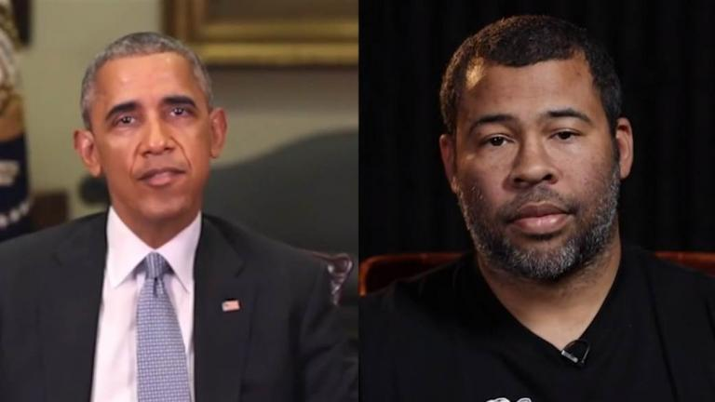
Deep fake videos have, for the most part, been relegated to corners of the internet outside the mainstream. But inevitable improvements to video editing software will better the deep fake product and make it more widely available for use, warns Bruce MacCormack, senior adviser to the Canadian Broadcasting Corp. and Radio-Canada.
TVNewsCheck 3.16.20
https://tvnewscheck.com/article/top-news/245953/deep-fake-videos-pose-growing-threat-to-news/?utm_source=Listrak&utm_medium=Email&utm_term=Deep+Fake+Videos+Pose+Growing+Threat+To+News&utm_campaign=Deep+Fake+Videos+Pose+Growing+Threat+To+News
Image credit:
http://wp.production.patheos.com/blogs/sites/944/2018/05/Deep-Fake-1.jpg

