Digital Ad Spend on Track to Hit $100B
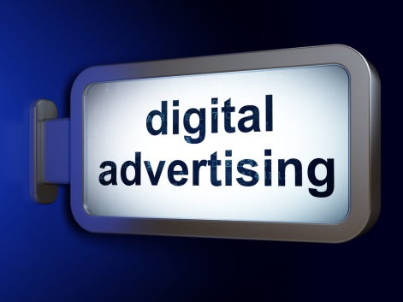
The Interactive Advertising Bureau reports that investment in digital ads spiked 23% in the first six months of this year to hit $49.5 billion, putting it on a trajectory to reach $100 billion for the first time by the end of 2018. Mobile took the largest digital ad spend share at 63%, according to the IAB's Internet Advertising Revenue Report.
TechCrunch 11/13/18
https://techcrunch.com/2018/11/13/iab-2018-report/
Image credit:
http://blog.orbitinformatics.com/wp-content/uploads/2015/09/digital-advertising.jpg

