Digital Content Revenue to Pass $200B In 2018
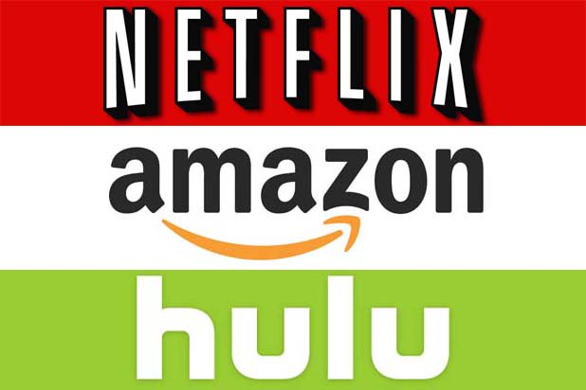
Juniper Research finds that SVOD services will be a key driver of growth, with major OTT players such as Netflix and Amazon committing budgets of more than $5 billion to original content over the coming year.
TVNewsCheck 11.9.17
http://www.tvnewscheck.com/article/108730/digital-content-rev-to-pass-200b-in-2018?utm_source=Listrak&utm_medium=Email&utm_term=Digital+Content+Rev+To+Pass+%24200B+In+2018+&utm_campaign=Sinclair+Also+Targeting+DOJ+Ownership+Cap
Image credit:
https://www.thewrap.com/wp-content/uploads/2014/06/digital-netflix-amazon-hulu.jpg

