Digital Continues Dominance Of US Media Spend
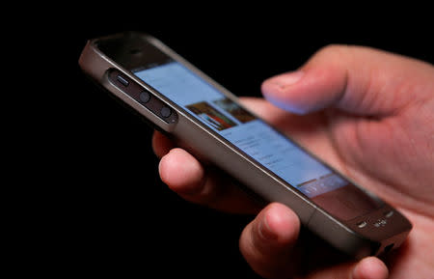
US digital ad spending will increase 12.5% this year to $248.72 billion, compared to a 37.2% increase in 2021, per updated Insider Intelligence forecasts. Digital media will continue to grow as a percentage of total media ad spending, hitting 71.8% of budgets this year, up from 55.6% in 2019, and it's forecast to be 80.9% of media budgets in 2026 to $385.47 billion.
Insider Intelligence 11/8/22
https://www.insiderintelligence.com/content/digital-us-media-ad-spend
Image credit:
https://s.yimg.com/ny/api/res/1.2/A.5RmkT6PwzJIx7F4Kf0gw--/YXBwaWQ9aGlnaGxhbmRlcjt3PTcwNTtoPTQ1Mw--/https://media.zenfs.com/en_us/News/Reuters/2018-09-23T231744Z_1_LYNXNPEE8M0S5_RTROPTP_2_ADVERTISING-DIGITAL.JPG

