Directors Are Livid About Netflix’s Plan to Speed Up Binge-Watching
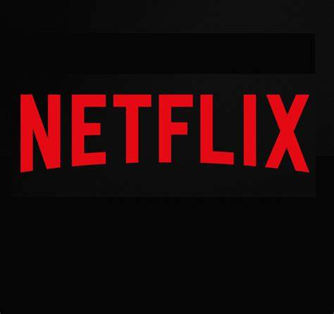
The streaming company is testing an option that would let users watch shows faster, according to Android Police. Some mobile users reported getting the choice to speed the pace of shows to 1.25x or 1.5x. Directors Judd Apatow and Peter Ramsey have urged Netflix to abandon any plans in the playback speed to honor their works’ intended timing.
New York Post 10.28.19
https://nypost.com/2019/10/28/directors-are-livid-about-netflixs-plan-to-speed-up-binge-watching/?utm_source=Listrak&utm_medium=Email&utm_term=Directors+Are+Livid+About+Netflix%26%23039%3bs+Plan+To+Speed+Up+Binge-Watching&utm_campaign=Viacom%2c+CBS+Move+Closer+To+Closing+Merger

