Disabled People Find Social Most Difficult Channel
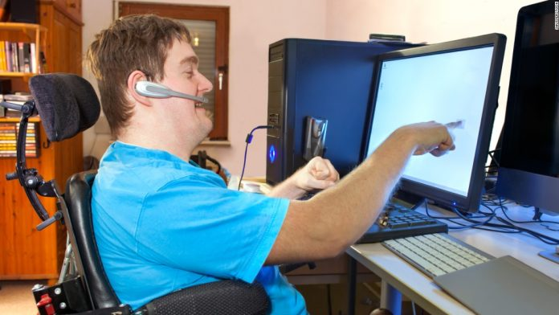
Social media platforms present the biggest accessibility difficulties for people with any disability across four categories in a study by IPG Mediabrands Magna -- visual, hearing, speech and cognitive. "This audience is consuming a lot of content, so brands need to ensure they put in the work to make communications more accessible," says Magna Global's Kara Manatt.
MediaPost Communications (free registration) 4/21/21
https://www.mediapost.com/publications/article/362542/ipg-mediabrands-finds-social-is-the-most-difficul.html
Image credit:
https://disabilitytalk.co.uk/app/uploads/2018/08/150723214120-08-ada-computer-screen-super-169-696x392.jpg

