Discovery-Warner Merger Review Looking Good, Says CFO
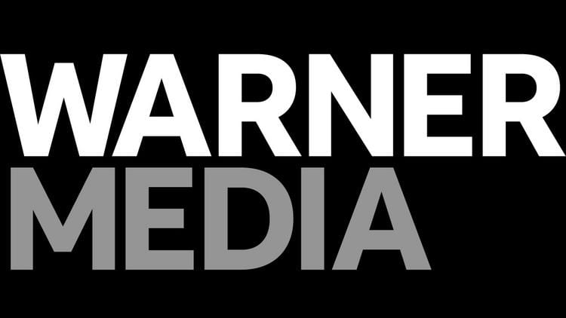
AT&T's Pascal Desroches, speaking to investors, said that WarnerMedia and Discovery are on track to close their merger by the middle of 2022 and that regulatory review is going well. Gunnar Wiedenfels told the same conference that the advertisement- supported version of Discovery+ brings in more revenue than the premium tier without ads.
FierceVideo 9/14/21
https://www.fiercevideo.com/programming/discovery-cfo-says-cheaper-version-discovery-draws-more-revenue

