Disney Likely To Buy All Of Hulu, Comcast Execs Say
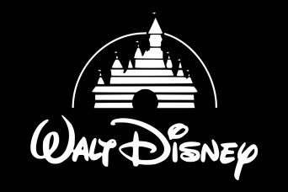
Some top Comcast executives reportedly believe that Disney will stick to a 2019 agreement in which it agreed to buy Comcast's remaining 33% Hulu stake, but hope that it decides to let NBCUniversal take over the streaming service instead. A buyout could happen any time after January 2024 and cost Disney at least $27.5 billion.
CNBC 9.2.22
https://www.cnbc.com/2022/09/02/comcast-executives-expect-disney-to-buy-remaining-stake-in-hulu.html

