Disney Movies Anywhere comes to Verizon FiOS
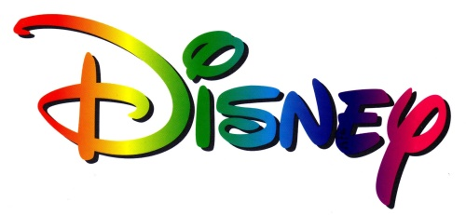
Verizon has signed a deal with Disney that enables FiOS customers to use the FiOS set-top or mobile app to connect to Disney Movies Anywhere's library of more than 450 films, which includes titles from Pixar and Marvel.
Multichannel News 8/23/16
http://www.multichannel.com/news/content/verizon-fios-first-mvpd-connect-disney-movies-anywhere/407221

