Disney’s Massive Streaming Gamble has Arrived
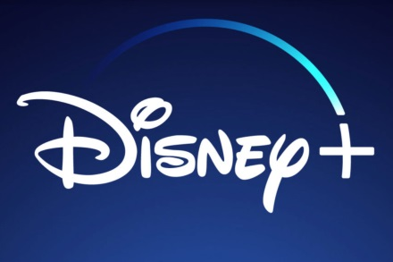
Disney has spent more than $3 billion on technology and content in an ambitious bid to take on Netflix at its own game. The $6.99-a-month service boasts a deep library, including movies and TV shows from Pixar Animation, “Star Wars,” Marvel Studios and classic Disney fare.
Los Angeles Times 11.12.19
https://www.latimes.com/entertainment-arts/business/story/2019-11-12/disney-plus-streaming?utm_source=Listrak&utm_medium=Email&utm_term=Disney%e2%80%99s+Massive+Streaming+Gamble+Has+Arrived.+It+May+Change+The+TV+Industry+Forever&utm_campaign=Disney+Streaming+Debuts+With+Hit+Brands

