Disney to Drop Netflix, Launch Own Streamer
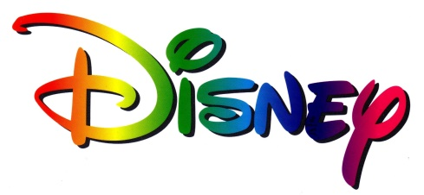
Disney is creating its own streaming service for its central Disney and Pixar brands and another for live sports. That would allow it to bypass the cable companies it relies on — and Netflix — to charge consumers directly for access to its popular movies and sporting events.
Associated Press 8.9.17
http://www.tvnewscheck.com/article/106313/disney-to-drop-netflix-launch-own-streamer?utm_source=Listrak&utm_medium=Email&utm_term=Disney+To+Drop+Netflix%2c+Launch+Own+Streamer&utm_campaign=Disney+To+Drop+Netflix%2c+Launch+Own+Streamer

