Dissecting The Possibilities For 5G
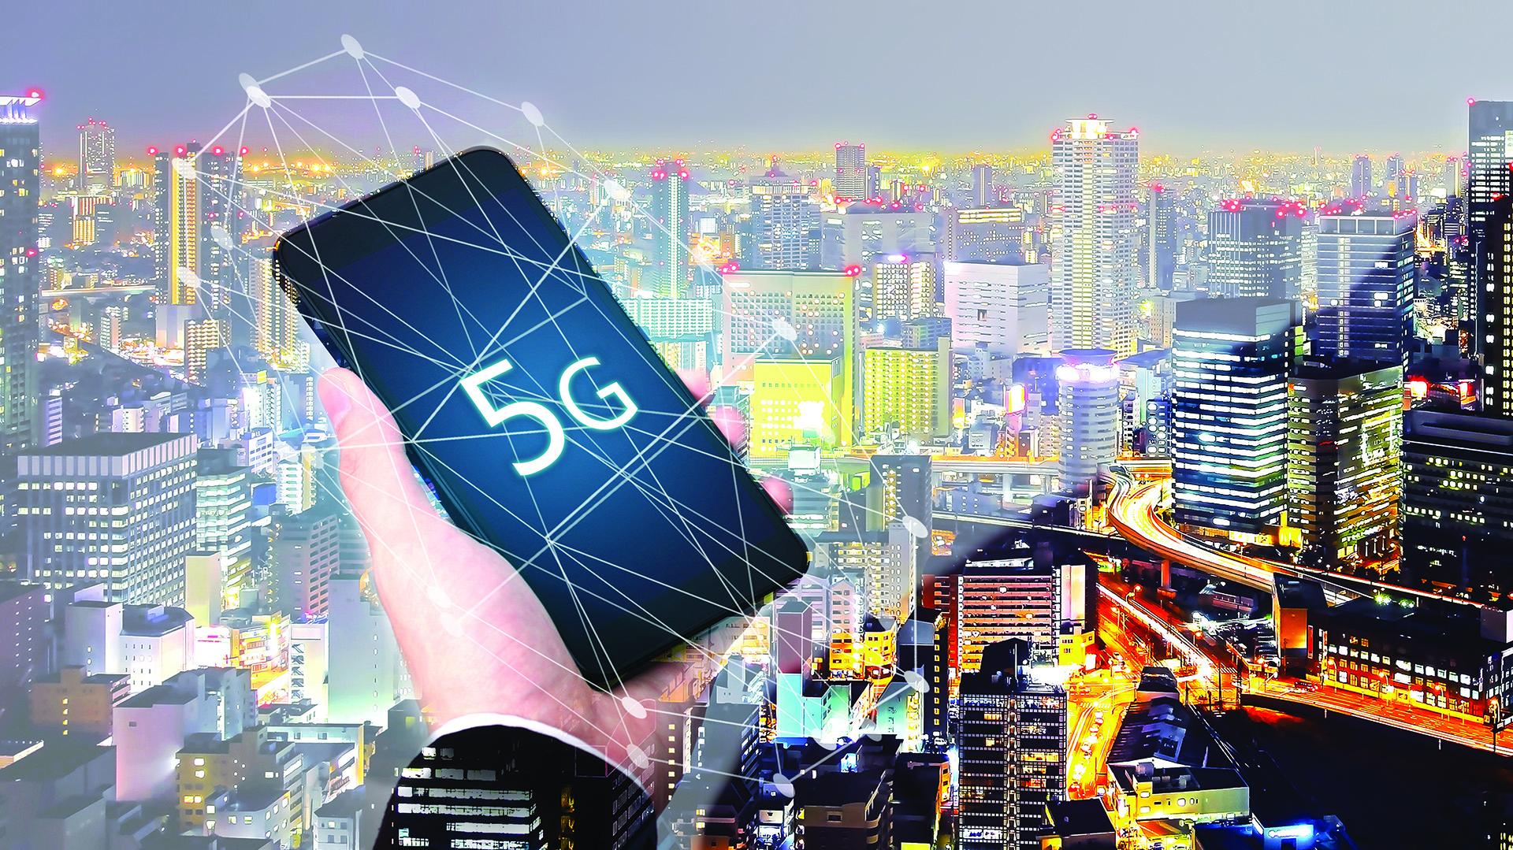
Potential applications include everything from accelerating the rise of so-called “smart cities” by connecting sensor networks that can manage traffic and resources, to connecting self-driving cars, facilitating high-speed connections that enable surgery and other telemedicine applications, helping companies automate their factories, and offering businesses dedicated high-speed internet lanes.
TVNewsCheck 9.6.19
https://tvnewscheck.com/article/top-news/238709/dissecting-the-possibilities-for-5g/?utm_source=Listrak&utm_medium=Email&utm_term=Dissecting+The+Possibilities+For+5G&utm_campaign=TV+Nets+Need+NFL+Ratings+Rebound+To+Continue
Image credit:
https://astanatimes.com/wp-content/uploads/2018/08/5G.jpg

