Ditch The GPS. It’s Ruining Your Brain
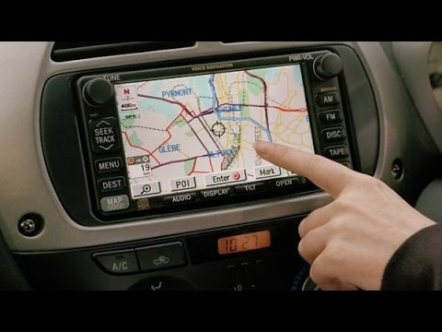
When people are told which way to turn, it relieves them of the need to create their own routes and remember them. They pay less attention to their surroundings. And neuroscientists can now see that brain behavior changes when people rely on turn-by-turn directions.
The Washington Post 6.5.19
https://www.washingtonpost.com/opinions/ditch-the-gps-its-ruining-your-brain/2019/06/05/29a3170e-87af-11e9-98c1-e945ae5db8fb_story.html?noredirect=on&utm_term=.006003b45bf0&wpisrc=nl_headlines&wpmm=1
Image credit:
https://i.ytimg.com/vi/F5uIW5yKw_g/hqdefault.jpg

