DogTV Launches SVOD Service for Dogs on Comcast
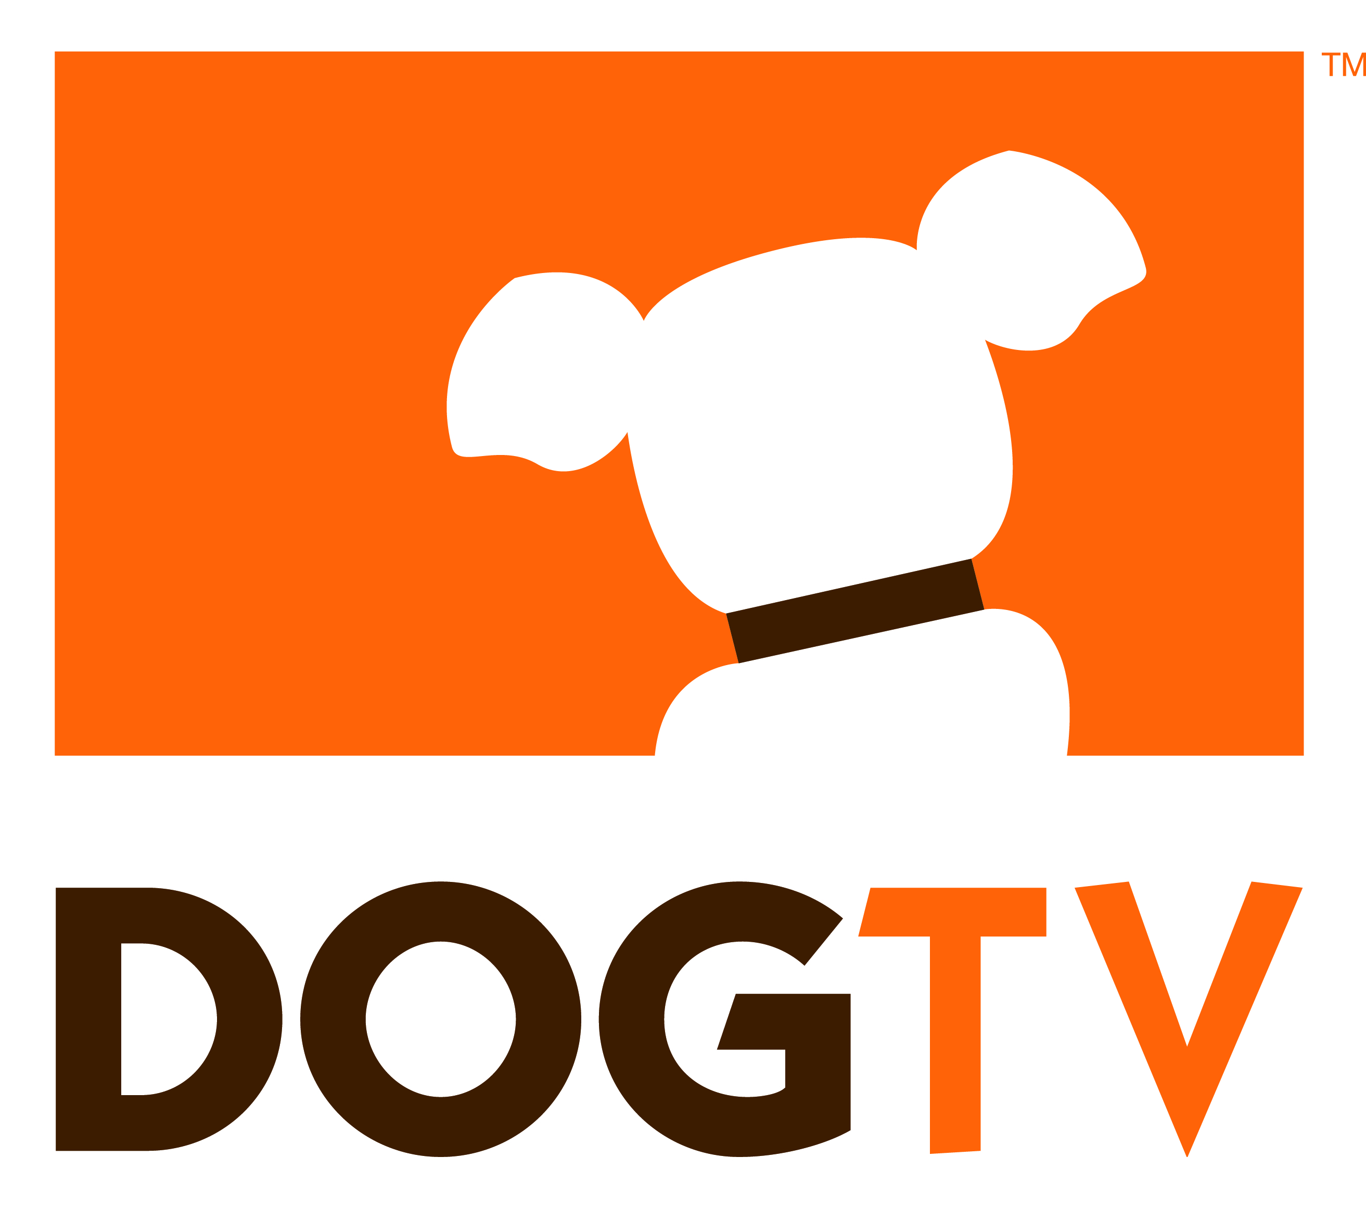
DogTV has launched a subscription-video-on-demand service on Comcast for $4.99 per month. The service includes original content that is "scientifically developed and tested" for dogs to view when their owners are away.
Broadcasting & Cable 4/21/17
http://www.broadcastingcable.com/news/technology/dogtv-collars-comcast-svod-deal/165103

