DOJ Charges 8 in High-Profile Digital Ad Fraud Case
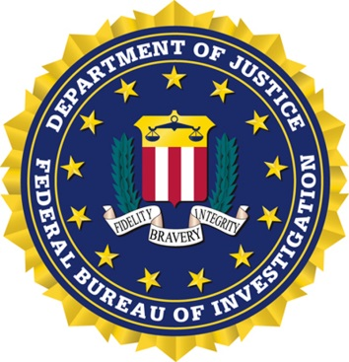
The FBI investigation into the global digital advertising fraud ring dubbed "3ve" has resulted in the Justice Department indicting eight men on 13 charges, including money laundering, aggravated identity theft and computer intrusion. The DOJ says the accused stole millions of dollars by employing "sophisticated computer programming and infrastructure around the world to exploit the digital advertising industry through fraud."
The Hill 11/27/18
https://thehill.com/policy/cybersecurity/418575-doj-unseals-charges-in-alleged-massive-online-ad-fraud

