DOJ Takes Steps To Protect Journalists' Rights
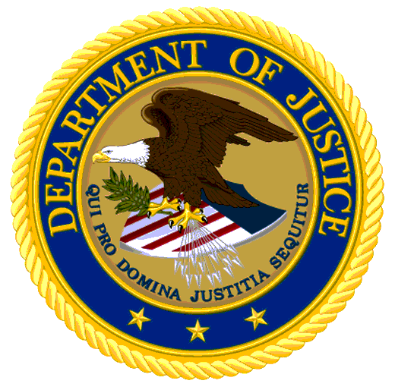
Merrick Garland, the US attorney general, has updated Department of Justice policies to prevent authorities from subpoenaing journalists' records when investigating government leaks. "Broadcasters appreciate Attorney General Garland for taking this important step, and we urge Congress to pass a federal shield law that would create long-lasting protections for a free and open press," said NAB leader Curtis LeGeyt.
Radio and Television Business Report 10.27.22
https://www.rbr.com/doj-revises-its-news-media-policy/

