New Milestone: DVR Viewing Tops Live
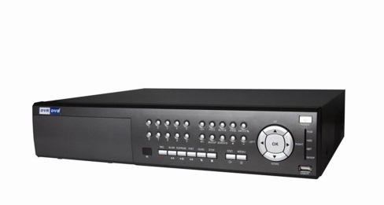
Two broadcast shows posted higher time-shifted than live numbers. “The Blacklist” and “Quantico” had a higher seven-day-DVR-playback (+7) rating than live-plus-same-day rating (L+SD), according to Nielsen data. And you can expect that number to get bigger as the season goes on.
MediaLife 11.3.15
http://www.medialifemagazine.com/milestone-dvr-viewing-tops-live-viewing/

