FCC Allots $68M In ECF Money To Help 100,000 Students
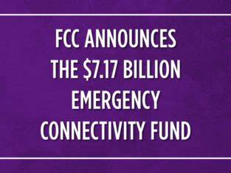
The FCC is sending nearly $68 million in broadband aid to help more than 100,000 students in several states with homework and other out-of-school activities in its latest tranche from the Emergency Connectivity Fund. The agency, to date, has committed $5.7 billion of its allocated $7.17 billion for schools, libraries and consortia.
Telecompetitor 8.11.22
https://www.telecompetitor.com/fcc-awards-68-million-in-emergency-connectivity-funding/
Image credit:
https://blog.ed.gov/files/2021/06/FCC-Blog_HR-1024x576.png

