Election Season Will Mean Windfall for Local TV
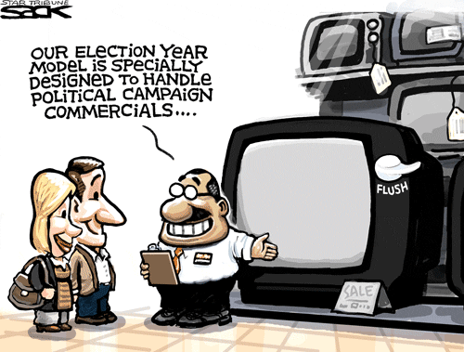
TV ad expenditures for the 2016 elections are expected to rise to $4.4 billion, up from $3.8 billion in the 2012 cycle. The big driver for the growth is the contested race for the White House among both Republicans and Democrats. "We haven't seen anything like this in the post-Citizens United era," said Elizabeth Wilner, senior vice president and head of Kantar's CMAG. "All of those contested races are going to produce enormous amounts of spending."
Variety 10/28/15
http://variety.com/2015/tv/features/political-ads-local-tv-pac-1201628302/

