Elevated Social Media Use Tied to Higher Odds of Teen Mental Health Problems
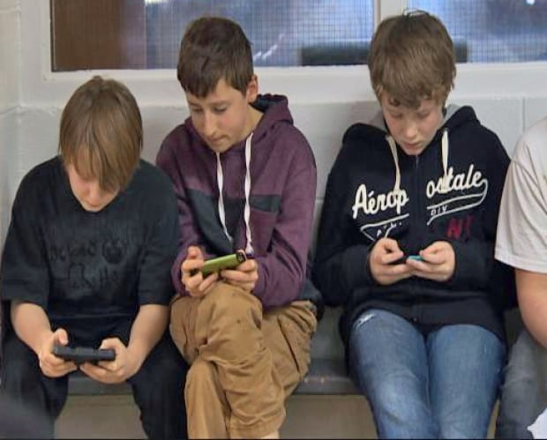
A study in JAMA Psychiatry showed that 12- to 15-year-olds who spent more than six hours on social media daily had a threefold higher likelihood of developing internalizing mental health problems, such as depression, as well as a fourfold increase in odds of developing both internalizing and externalizing issues, such as bullying, compared with those who used no social media. Shorter duration of social media use was also associated with increased risk, but the association between social media use and externalizing behaviors alone was inconsistent.
HealthDay News 9/11/19
https://consumer.healthday.com/kids-health-information-23/adolescents-and-teen-health-news-719/lots-of-time-on-social-media-linked-to-anxiety-depression-in-teens-750216.html
Image credit:
https://i.cbc.ca/1.2543524.1392832319!/fileImage/httpImage/image.jpg_gen/derivatives/original_620/teen-social-interaction.jpg

