Elon Musk To Acquire Twitter For $44B
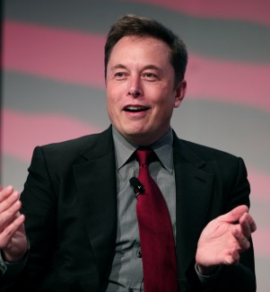
Twitter's board unanimously approved a $44 billion deal to sell the platform to Elon Musk, pending stockholder approval, valuing its shares at $54.20 each. Musk stated he wants to make Twitter "better than ever by enhancing the product with new features, making the algorithms open source to increase trust, defeating the spam bots and authenticating all humans."
Adweek 4/26/22
https://www.adweek.com/media/elon-musk-to-acquire-twitter-in-deal-valued-at-roughly-44b/
Image credit:
https://one37pm.imgix.net/one37pm-editor-dev-images/s3fs-public/user-images/2020-09/elon-musk-mobile.jpg?ch=Width,DPR&auto=compress&q=60&w=1&fit=clip&dpr=2

