Engagement, Social Listening Can Improve Brand Reputation
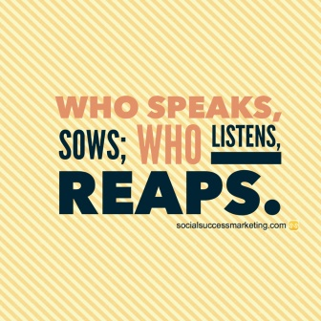
Brands that want to build consumer trust and their overall reputation should demonstrate their value, engage with their audience, improve customer service with tools such as chatbots and engage in social listening to "identify pain points," writes Jared Atchison. He urges communications professionals to remember, "reputation is much easier to lose than it is to gain."
Business 2 Community 10/31/20
https://www.business2community.com/customer-experience/4-tips-for-boosting-your-brand-reputation-02358326
Image credit:
https://i0.wp.com/socialsuccessmarketing.com/wp-content/uploads/2015/05/social_media_listening_who_reaps_sow_quote.jpg

