School Esports Can Boost Academics, Critical Thinking
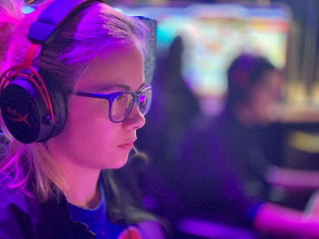
College scholarship money for esports -- which hit $16 million in 2020-21, a sports association reports -- is one reason students play on high-school teams, but esports also helps with life skills. Randy Miller, a Pennsylvania high school's curriculum director, says esports players are "focusing on academics, ... sportsmanship, the ability to work with others, strategic thinking, time management, handling wins and losses" and interacting in a positive environment with other students.
KFSM-TV (Fort Smith, Ark.) 10/5/23
https://www.5newsonline.com/article/sports/esports-scholarship-high-school-students-across-arkansas/527-f2346dfa-d057-473c-abdb-fee098550d3b
Image credit:
https://www.bing.com/images/search?view=detailV2&ccid=B9M39HJT&id=8A113C5D7F4D83A185E14C282EFF56219D0D02C0&thid=OIP.B9M39HJT1kDx30TeHY1oUwHaFj&mediaurl=https%3a%2f%2fwww.kemperlesnik.com%2fwp-content%2fuploads%2f2020%2f08%2fBoise-State-University-Esports-Student.jpg&cdnurl=https%3a%2f%2fth.bing.com%2fth%2fid%2fR.07d337f47253d640f1df44de1d8d6853%3frik%3dwAINnSFW%252fy4oTA%26pid%3dImgRaw%26r%3d0&exph=3024&expw=4032&q=college+esports&simid=607991430661278936&FORM=IRPRST&ck=C24FFC422ED87EDBF77EA1DE9FF3D5AE&selectedIndex=12&ajaxhist=0&ajaxserp=0

