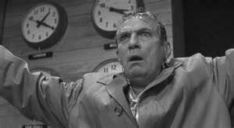
Network - Ethical Decision Making, specifically, this is to critique (assess) the treatment of Howard Beale by one of the primary characters in the movie Network. You must use the Potter’s Box to complete the assignment. Read your Media Now text for instructions on using the Potter’s Box.

The first step in the Potter’s Box is to provide extensive details to define the situation. For this assignment they are the actions taking place concerning the character Howard Beale.
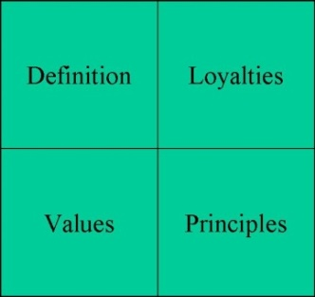
Second, define and discuss the values. These values are found in the Radio, Television, Digital, News Association (RTDNA) ethics code. The RTDNA code is specific to electronic news.
Third, identify and discuss the appropriate principles that you believe are important to this matter. The book reprints information on the ethical principles.
Fourth, identify and explain the loyalties of one of the following, Max Schumacher, Diana Christensen, or Frank Hackett.
Once you complete all four aspects of the Potter’s Box you must present a statement to answer the question. Was it acceptable to put Howard Beale on the air after his initial outburst?
Answer the question but in so doing you must not only define the situation, cite the appropriate ethical principle(s) and values (professional code) and loyalties, but must also explain why each is important to your answer. A comprehensive answer presents a balanced perspective; an answer that does not merely confirm your position.

Network (1976) – directed by Sidney Lumet
Characters …………..Actors
Diana Christensen .….Faye Dunaway
Max Schumacher …...William Holden
Frank Hackett ……….Robert Duvall
Howard Beale ……….Peter Finch

Document Layout:
Cover page title is, “Network -Ethical Decision Making”, and includes your name and date.

Peter Finch as Howard Beale

Image credit: http://www.wsws.org/articles/2011/apr2011/lume-a20.shtml

Report content:
Title each of the 5 sections. Write 2-4 paragraphs per section.
- Definition
- Values
- Loyalties
- Principles
- Statement
Double-space text. Proper spelling and grammar will count toward the grade. A citation page is not needed but if you reference other work (web site, etc.) in your paper you must credit the source using end notes in MLA style. Failure to cite sources is plagiarism and is likely to result in failing the assignment.

Please expect to discuss this in class – to share your responses and hear what others have decided. You will be asked to take notes as part of the assignment.

The assignment is due:

___________________________

