Excessive Screen Time in their Rooms Can Negatively Impact Children
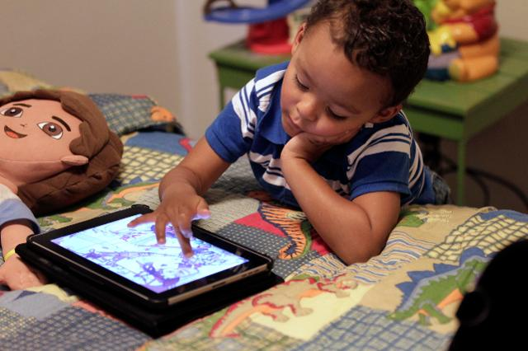
A review of three studies that examined the effects of digital devices in the bedroom has concluded that excessive time spent with "bedroom media" can harm children's performance in school, increase risk of obesity and lead to aggressive behavior depending on the type of media consumed. The team of researchers also noted that children who spend more time watching television or playing video games read and sleep less than children who don't have 24-hour access to media.
Psychology Today 10/6/17
https://www.psychologytoday.com/blog/media-spotlight/201710/how-do-bedroom-digital-devices-affect-children
Image credit:
https://specials-images.forbesimg.com/imageserve/548f4065d2b14e0ea935a59918ff6fe1/640x0.jpg?fit=scale

