Facebook Grapples With Site Safety
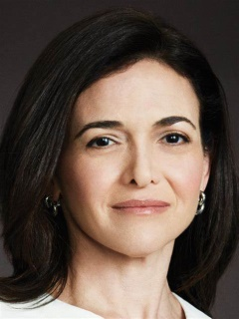
Sheryl Sandberg, Facebook's chief operating officer, reiterated the platform's call for regulation amid brand safety issues, a rising tide of privacy initiatives and calls for the platform to break up, saying tech companies shouldn't be making all of the decisions.
CNET 6/19/19
https://www.cnet.com/news/facebook-coo-sheryl-sandberg-reiterates-that-her-company-needs-to-be-regulated/
Image credit:
https://www.bing.com/images/search?view=detailV2&ccid=vcKVvA1t&id=2D75D6DEE7A2571FCF9A788BE806C4E7DB5B26A1&thid=OIP.vcKVvA1tWnviiMnX3ECSKAHaJ4&mediaurl=http%3a%2f%2fwww.followthegls.com%2fwp-content%2fuploads%2f2017%2f04%2fTGLS2017_Sheryl_Sandberg.jpg&exph=900&expw=675&q=SHERYL+SANDBERG&simid=608029087212047347&selectedIndex=24&ajaxhist=0

