Facebook Offers In-Stream-Only Video Ad Buys
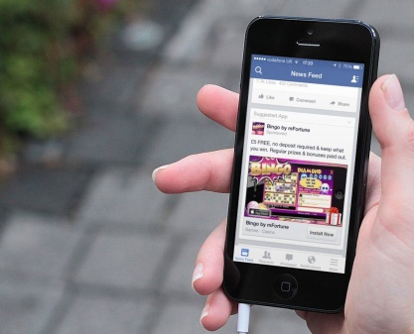
Advertisers can buy video ads from Facebook that will only be served when people are viewing a video, increasing the likelihood that people will watch them. In other words, video-hungry advertisers can finally buy video ads from Facebook that will only run in the same context as the ads they buy from YouTube, Hulu and TV networks — in-stream video ads that people will be more likely to watch, and watch with the sound on.
Marketing Land 8.17.17
http://marketingland.com/facebook-looks-to-rival-youtube-tv-with-in-stream-only-video-ad-buying-option-222079
Image source:
https://cdn.cultofandroid.com/wp-content/uploads/2013/10/Facebook-ad-iPhone.jpg

