Facebook, Universal Music Group Partner on Music Use
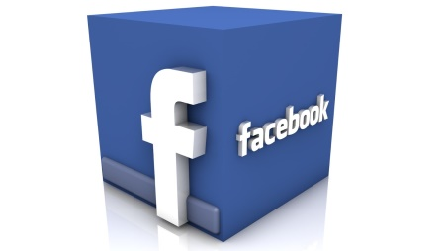
Facebook and Instagram users will be able to upload videos from Universal Music Group's catalogs in a new multiyear deal between Facebook and UMG. The agreement comes after YouTube made a deal with UMG as part of next year's expected paid-subscription plans.
The Drum (Scotland) 12.21.17
www.thedrum.com/news/2017/12/21/facebook-strikes-first-major-music-rights-deal-with-universal-music

