Facebook Purchases GIPHY, Tests New In-Stream Ad Format
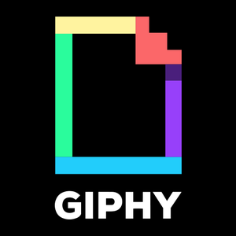
Facebook acquired GIPHY for roughly $400 million and will make it part of Instagram, making GIPHY's animated images available through Facebook's apps, which could become "a new avenue for Facebook to help brands develop customized ad campaigns," writes MediaPost's Gavin O'Malley. Facebook also began testing mid-roll in-stream video ads that feature a countdown timer and button viewers can click after five seconds to skip ahead.
Axios 5.15.20
https://www.axios.com/scoop-facebook-to-buy-giphy-for-400-million-4a75a359-833b-484d-b15b-87e94d3de017.html

