Facebook Purges Billions of Accounts
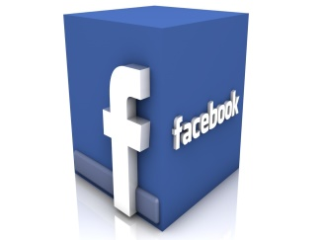
As part of an ongoing effort to clean house, Facebook deleted more than 3 billion fake accounts during the first six months of 2019 and another 7.3 million posts, photos and other objectionable material, according to company reports, which attribute the increase in activity to "automated attacks by bad actors who attempt to create large volumes of accounts at one time."
ABC News/The Associated Press 5/23/19
https://abcnews.go.com/Technology/wireStory/facebook-removes-3b-fake-accounts-missed-63230150

