Facebook Vows Transparency on Political Ads
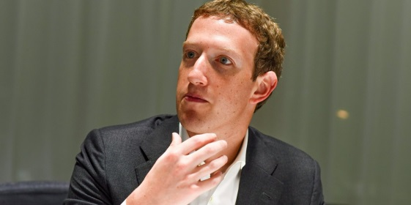
In the wake of revelations that thousands of Russian-backed 2016 political ads were taken out on Facebook, CEO Mark Zuckerberg pledged that the platform will strengthen its review process. He said that Facebook will also increase transparency for the political ads it receives in the wake. "Not only will you have to disclose which page paid for an ad, but we will also make it so you can visit an advertiser's page and see the ads they're currently running to any audience on Facebook," he wrote.
Facebook 9.22.17
https://www.facebook.com/zuck/posts/10104052907253171
Image source:
http://static6.businessinsider.com/image/56d324122e526556008ba1a1-1190-625/mark-zuckerberg-we-shouldnt-worry-about-ai-overtaking-humans-unless-we-really-mess-something-up.jpg

