Failure to Evolve TV Ratings System Could Lead to Lost Ad Revenue
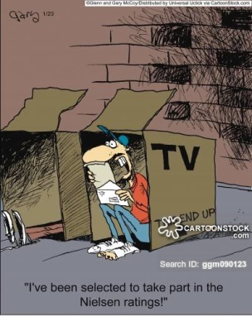
The TV industry is at odds regarding how to evolve ratings measurement, and failure to come to a consensus could lead to lost ad revenues, writes Brian Steinberg. "We have fracturing consumer usage that we know is going from linear TV to over-the-top, to VOD, to mobile -- and we don't have a good way to re-aggregate those audiences that is believable and reliable," says Magna's David Cohen.
Variety 4/11/17
http://variety.com/2017/tv/features/nielsen-total-content-ratings-1202027752/
Image source:
https://s3.amazonaws.com/lowres.cartoonstock.com/technology-nielsen-ratings-market-research-researches-ggm090123_low.jpg

