Fake News is About to Get so Much More Dangerous
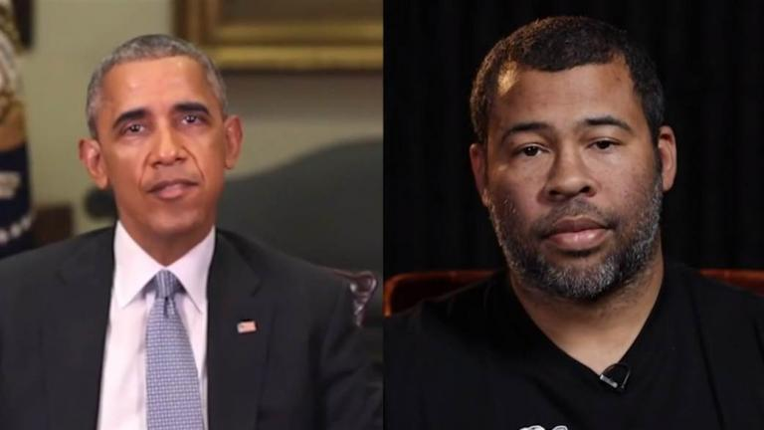
If technology continues its current advance, we may soon face totally convincing videos showing events that never happened — created so effectively that even experts will have trouble proving they’re fakes.
The Washington Post 9.6.18
https://www.washingtonpost.com/opinions/fake-news-is-about-to-get-so-much-more-dangerous/2018/09/06/3d7e4194-a1a6-11e8-83d2-70203b8d7b44_story.html?utm_term=.87def21ba818&wpisrc=nl_opinions&wpmm=1

