DraftKings, FanDuel Keep Pouring Cash Into TV
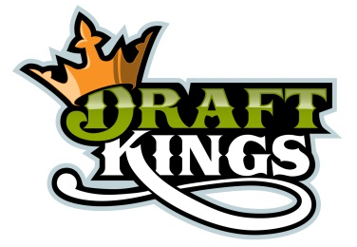
According to iSpot.tv estimates, DraftKings and FanDuel together have funneled $107 million into the networks' coffers since Sept. 1. Nearly half ($50.3 million) of that outlay was spent on national NFL broadcasts on CBS, Fox, NBC, ESPN and NFL Network.
Advertising Age 9.30.15
http://adage.com/article/media/draftkings-fanduel-spe/300658/?utm_source=daily_email&utm_medium=newsletter&utm_campaign=adage&ttl=1444181728

