FAST Studios Will Provide Content for Free Streamers
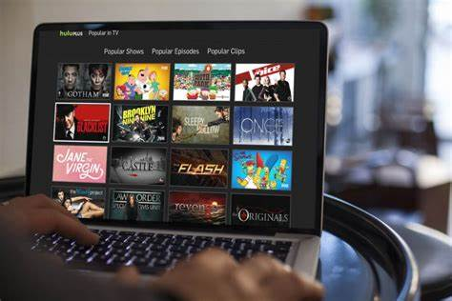
Startup FAST Studios is developing and investing in content to support free, advertisement-supported streaming television providers. FAST will also create channels to run on platforms such as Pluto TV, Xumo, Tubi and the Roku Channel.
Light Reading 2/8/21
https://www.lightreading.com/cablevideo/fast-studios-banks-on-rise-of-free-streaming/d/d-id/767237
Image credit:
https://static.techspot.com/images2/news/bigimage/2017/04/2017-04-24-image.jpg

