FCC, FTC to Partner to Police Internet
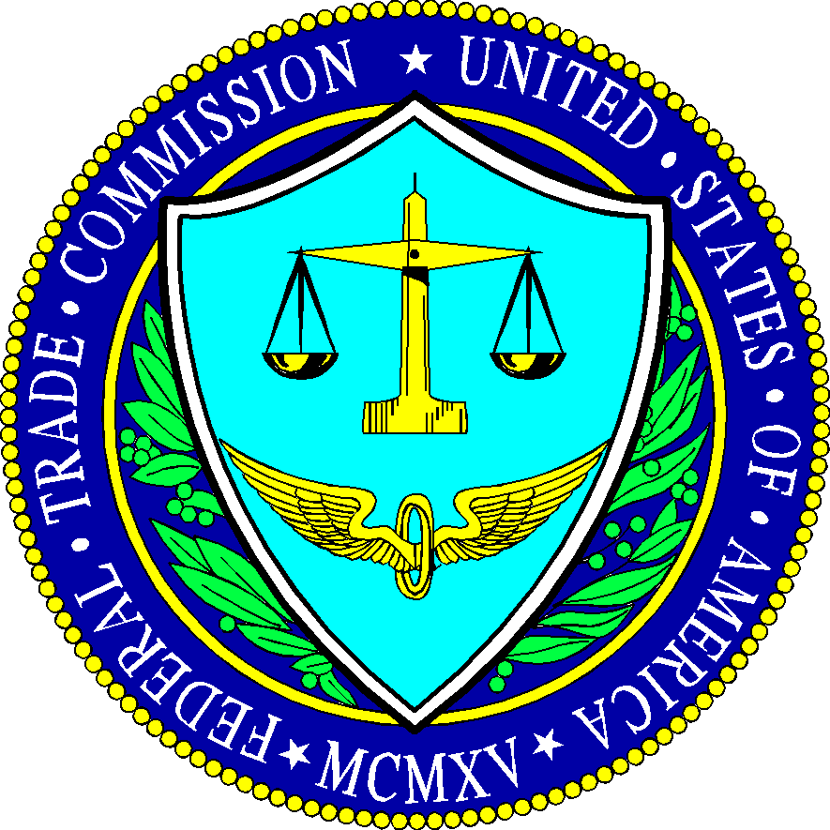
The Federal Trade Commission and the FCC announced an agreement on Monday to coordinate their efforts to police the internet once the latter agency has repealed its net neutrality rules set for a vote on Thursday.
The Hill 12.12.17
http://thehill.com/policy/technology/364336-fcc-ftc-announce-partnership-to-police-internet-after-net-neutrality-repeal

