FCC Allocates $68M From ECF To Aid About 110,000 Students
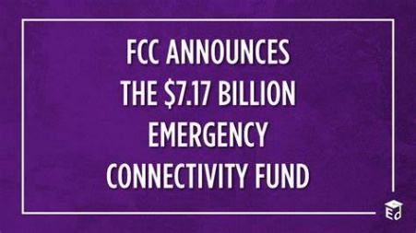
The FCC doled out $68 million from its Emergency Connectivity Fund to help roughly 110,000 students connect to broadband service. The latest outlay will provide aid to 13 libraries, two consortia and 184 schools in Arizona, Connecticut, Indiana, Maryland, Massachusetts, New Mexico and Washington.
Telecompetitor 8/24/23
https://www.telecompetitor.com/fcc-gives-seven-states-68m-for-student-broadband/
Image credit:
https://blog.ed.gov/files/2021/06/FCC-Blog_HR-1024x576.png

