FCC Allots $800M From RDOF Across 19 States
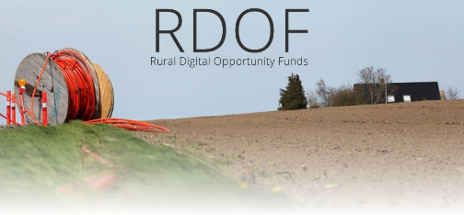
The FCC is doling out $792 million from its $20 billion Rural Digital Opportunity Fund to support broadband projects in unserved rural areas in 19 states with the largest shares going to Arizona, Iowa and Illinois. The new round is geared to providers using licensed spectrum on fiber or fixed wireless services.
Next TV 9.1.22
https://www.nexttv.com/news/fcc-approves-dollar800-million-more-in-broadband-aid?utm_source=SmartBrief&utm_medium=email&utm_campaign=3E572E13-3FBC-11D5-AD13-000244141872&utm_content=39E84547-88B3-4A00-89F5-211BA81469E4&utm_term=A25693A1-51B6-4112-BDE4-56BD420E983F
Image credit:
https://techkalture.com/wp-content/uploads/2020/12/RDOF-Rural-Digital-Opportunity-Funds.jpg

