FCC Announces Fee Increases For Radio Applications
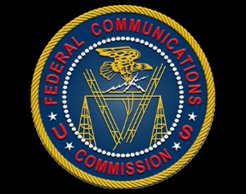
The FCC has announced plans to update its Schedule of Application Fees based on the 11.6% increase in the Consumer Price Index. Radio stations will face higher costs for construction permits, license renewals, change applications and other FCC applications.
Radio World 12/18/22
https://www.radioworld.com/news-and-business/headlines/fcc-hikes-radio-application-fees?utm_term=A25693A1-51B6-4112-BDE4-56BD420E983F&utm_campaign=45863C53-9E40-4489-97A3-CC1A29EF491D&utm_medium=email&utm_content=74BA266C-6F9B-4DD1-A065-67B5D6281828&utm_source=SmartBrief

