FCC's CP Auction Gets 158 Applications
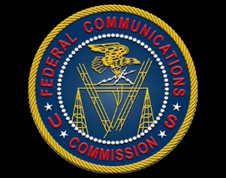
The Federal Communications Commission has received applications from 158 parties hoping to bid in its July auction, which will sell off construction permits for 136 FM radio stations and four AM stations. The agency rejected one application and says 50 need to provide more information before it announces the list of eligible bidders in early July.
Radio World 6.3.21
https://www.radioworld.com/news-and-business/business-and-law/fcc-receives-158-applications-for-cp-auction?utm_source=SmartBrief&utm_medium=email&utm_campaign=45863C53-9E40-4489-97A3-CC1A29EF491D&utm_content=0B94058F-32A4-4313-8087-4A5F593170BE&utm_term=a25693a1-51b6-4112-bde4-56bd420e983f

