FCC Clarifies Upcoming Windows for Construction Permits
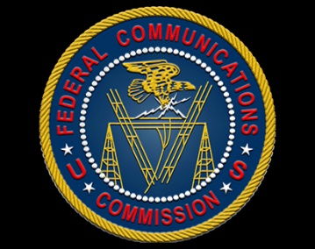
The dates for this NCE filing window have not yet been announced. Presumably, the filing dates will be set once this order on application limits is finally adopted by the FCC. If you are a nonprofit, educational entity interested in pursuing an application in this window, stay alert for the announcement of the dates for filing applications in this window.
Broadcast Law Blog 4.5.21
https://docs.fcc.gov/public/attachments/DA-21-361A2.pdf

